Charles Simpson
Advanced Programming
Dr. Sazegar
April 23, 2026

Mini-Lab: Ethics and Data Analysis

Introduction
The main objective of this mini-lab is to learn how to craft a secure FastAPI backend by implementing the JWT (JSON Web Token) authentication. In addition, we will also learn how to incorporate the data from the Mastercard Inclusive Growth Score (IGS) into an SQLite database and visualize the data provided by creating a Streamlit dashboard. Afterwards, we will tackle how to go about with addressing ethical concerns such as bias and privacy, utilize different data structures (sets, lists and dictionaries), and work through five challenge problems to test our knowledge on the matter. Finally, the lab will wrap up with us being able to locally deploy the application, build a dashboard wireframe, and to report our findings.

Dataset Import
The primary function of SQLite import is to be able to store all of the data within a database that doesn’t require the use of a server as demonstrated in the following screenshot below taken from PyCharm.

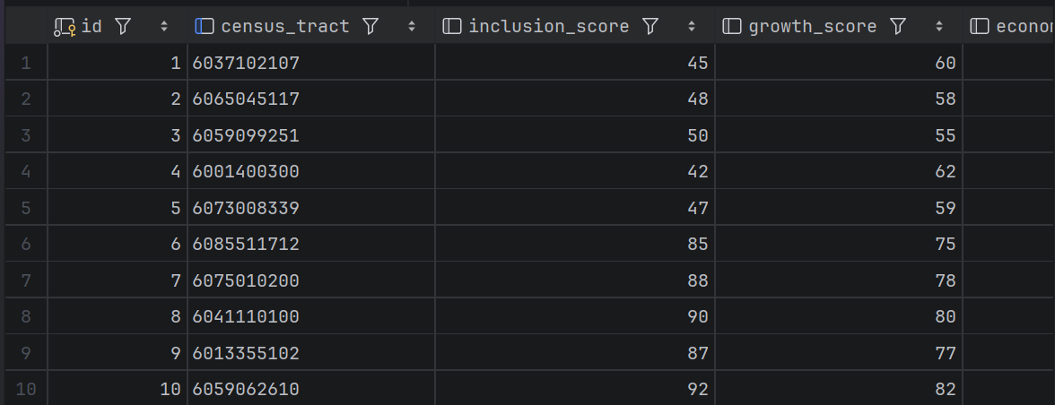FastAPI
Due to the sensitive nature of the data that is being stored, the IGS database, the purpose of implementing the FastAPI along with the JWT authentication is to construct an authentication system that encodes the data from the database as well as create and verify JWTs to provide safer and more secure authentication when accessing the data. The following screenshot is what is created from implementing the FastAPI and JWT authentication methods.
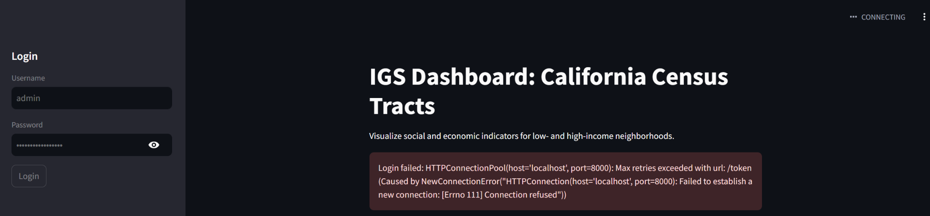
As stated above, programmers won’t be able to access the sensitive database information without entering a proper username and password into the system. Finally, all usernames and passwords created and entered into the system are hashed and encrypted by utilizing bcrypt.

Streamlit
Continuing on, the main functionality behind the usage of dashboard is to create an interactive dashboard/screen where the programmer would have to input the necessary credentials to access the information from the IGS database and in addition to this, it also displays the data from the database depending on what graph the programmer chooses to implement. As presented in the previous screenshot in the FastAPI section, the code creates an interactive dashboard that requires the programmer to enter the correct credentials. Afterwards, the dashboard should then take the programmer to a visual representation of the database as seen from the screenshot in the Database Import section.

Ethics
In terms of some of the major ethical problems that may arise, the major five include: the presence of bias in the IGS data, privacy protection, accountability, transparency, and fairness in decision-making. To circumvent each of these issues, the following must occur for each problem:
- Accountability
  - To make sure that there is accountability within the data being presented, it is essential that programmers implement an ethical review process as one of the apps within the main.py file.
- Bias in IGS Data
  - Programmers should likely take into account other readily available public datasets such as a dataset based on homelessness or perhaps the job market, or the like and incorporate these datasets alongside the primary IGS dataset being used.
- Transparency
  - To make sure that the data being presented is presented with the utmost transparency, programmers should look to integrate a methodology section within the dashboard to highlight the programmers’ intentions when accessing, updating, or creating the database.
- Privacy Protection
  - In order to increase the privacy protection of the IGS database so that it doesn’t become re-identifiable when joined with other databases, adding in different privacy options, especially to specific fields like scores, can help within this field.
- Fairness in Decision-Making
  - To ensure fairness when accessing, updating, or storing data within the database, adding in fairness metrics of different tracts will allow the programmers accessing the information to compare the results and make them mindful of how to go about with utilizing the data.

Test Results
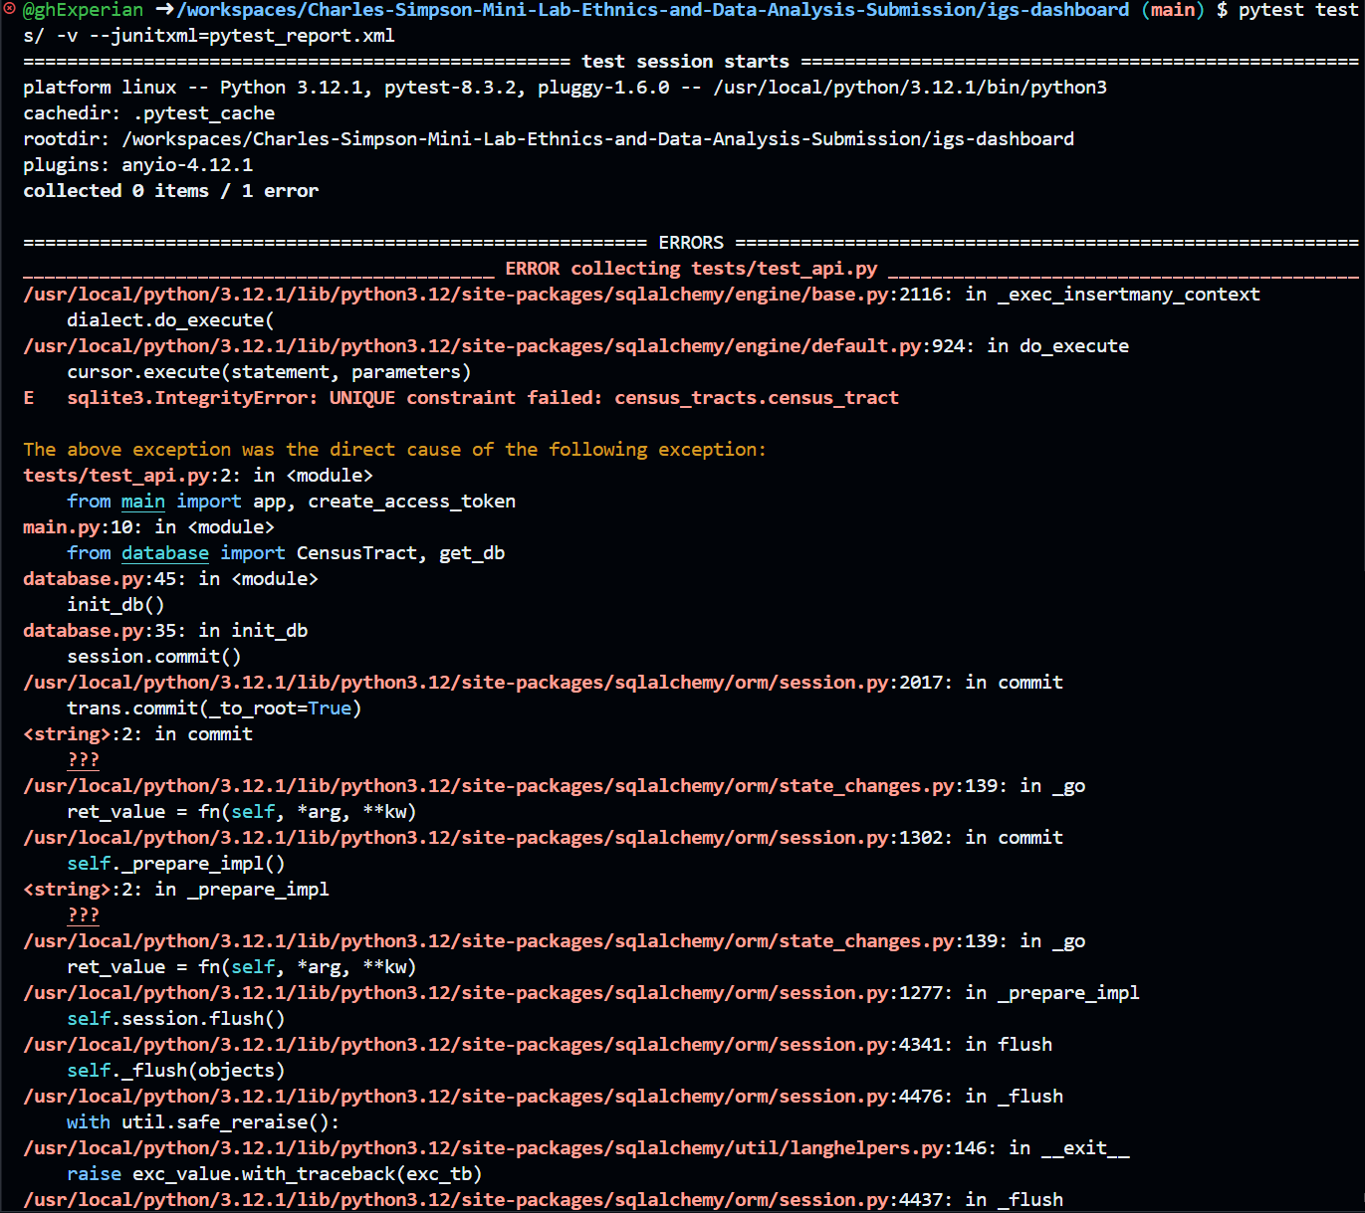
As you can see in the screenshot above, when I went to get the test results of the entire application, it returned an error. This is most likely due to the fact that I was unable to access the database from the login and make the necessary changes that I needed to in terms of adding the scatterplot, adding the different limitations to the database, and overall just being prevented of what I needed to do in order to make everything work properly.

Conclusion
In summary, this mini-lab was designed to show us how to utilize FastAPI as well as Steamlit to and JWT authentication to securely store sensitive information from a dataset, the IGS database, through the means of a login. In addition, we also learned about some of the ways that we can go about ensuring ethical integrity when storing, accessing, or updating the databases with very sensitive information. As for me, while the logic of all of the steps and processes to using APIs in this way makes sense, actually writing the code and getting it to work properly has always been where I struggled. One day, I will be able to easily write the code and encounter very few problems, but until then, I will keep persevering to perfect the techniques even after graduating next month.

GitHub Repository Link
https://github.com/ghExperian/Charles-Simpson-Mini-Lab-Ethnics-and-Data-Analysis-Submission/blob/e0059134f147af22814c9cd725b4d7f564296dec/igs-dashboard/pytest_report.xml

